**Loan Data Analysis Documentation for TDI**

**1. Problem Statement**

The Loan Data Analysis Dashboard for TDI addresses the following challenges:

* **High Default Rates**: Understand factors contributing to loan defaults by analyzing borrower profiles and loan statuses.
* **Borrower Risk Profiles**: Identify key risk indicators such as debt-to-income ratios, employment length, and homeownership, and their impact on loan performance.
* **Interest Rate Optimization**: Analyze the relationship between loan interest rates and borrower risk to help TDI optimize lending strategies.
* **Loan Performance Tracking**: Monitor loan repayment patterns over time to improve loan issuance decisions and manage risk effectively.

**2. Data Cleaning & Preparation**

* **Empty Cells Handling**:
  + Replaced empty cells in the emp_title column with "Unknown".
  + Removed empty rows with no data.
* **Data Formatting**:
  + Renamed the home_Oership column to Home_Ownership.
  + Imported a CSV of state abbreviations and regions, using VLOOKUP to fill in state names and regions.
  + Applied PROPER() to the emp_title column and removed the original column.

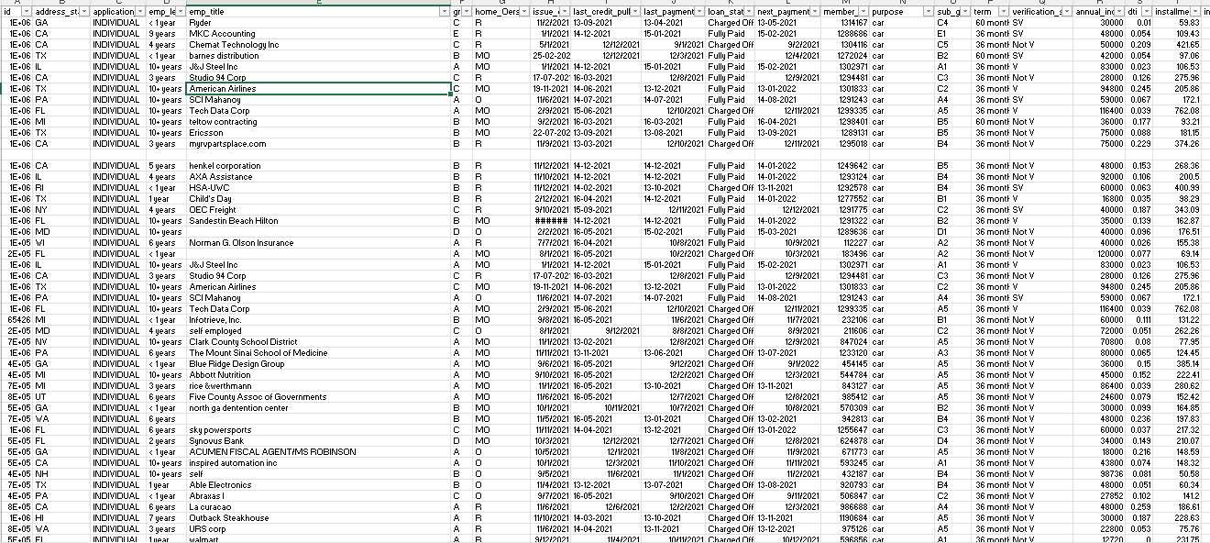

* **Column Editing**:
  + Edited the home_ownership column (O → OWN, MO → Mortgage, R → Rent) and applied PROPER() to "None" and "Other".
  + Edited the verification_status column (SV → Source Verified, V → Verified, NV → Not Verified).
  + Used "Text to Column" to split issue_date, last_credit_pull_date, last_payment_date, and next_payment_date.
  + Removed "months" from the term_length column and formatted it as a number.
* **Data Type Formatting**:
  + annual_income as currency, dti as percentage, installment as currency, int_rate as percentage, loan_amount as currency, total_acc as number, and total_payment as currency.
* **Missing Values**:
  + For empty loan_amount, replaced with average loan amount.
  + For empty total_payment, calculated based on the "Fully Paid" status and filled in the value.

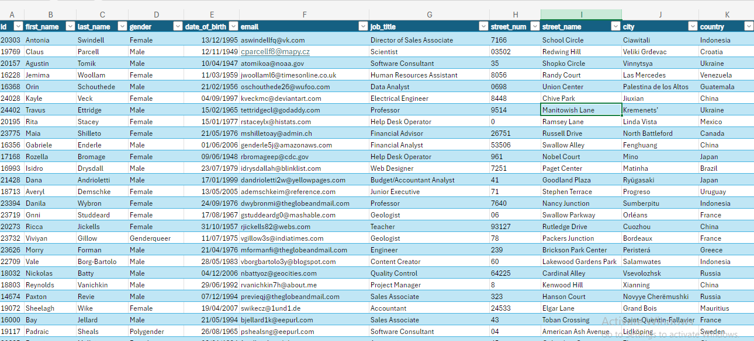

**3. Data Analysis**

**Calculated Fields**

* **Monthly Debt Payment**:
  + Formula: =ABS(PMT(Interest Rate, Term_Length (in months), Loan_Amount)).
* **Debt-to-Income (DTI)**:
  + Formula: monthly debt payment / loan amount * 100.
* **Loan-to-Income (LTI)**:
  + Formula: loan amount / annual income * 100.
* **Default Loans**:
  + Formula: =IF([Loan_Status] = "Charged Off", 1, 0).
* **Income Bracket**:
  + Created income brackets: Low Income (<$50,000), Lower-Middle Income ($50,001 - $150,000), Middle Income ($150,001 - $500,000), Upper-Middle Income ($500,001 - $1,000,000), High Income (>$1,000,000).

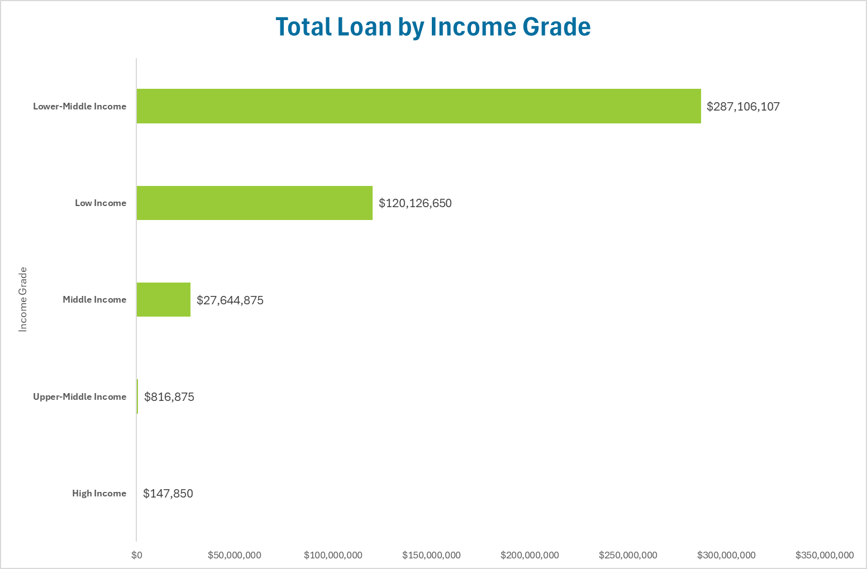

* **Default Rate**:
  + Formula: SUM(Default loan) / TOTAL LOANS.

**Interest Rate Brackets**

* **Interest Grade**:
  + Low (≤10%), Medium (11-15%), High (16-20%), Very High (>20%).

**Employment Length Brackets**

* **Employment Length Bracket**:
  + Created categories for employment length: <1 year, 1 to 3 years, 3 to 5 years, 5 to 10 years, 10+ years.

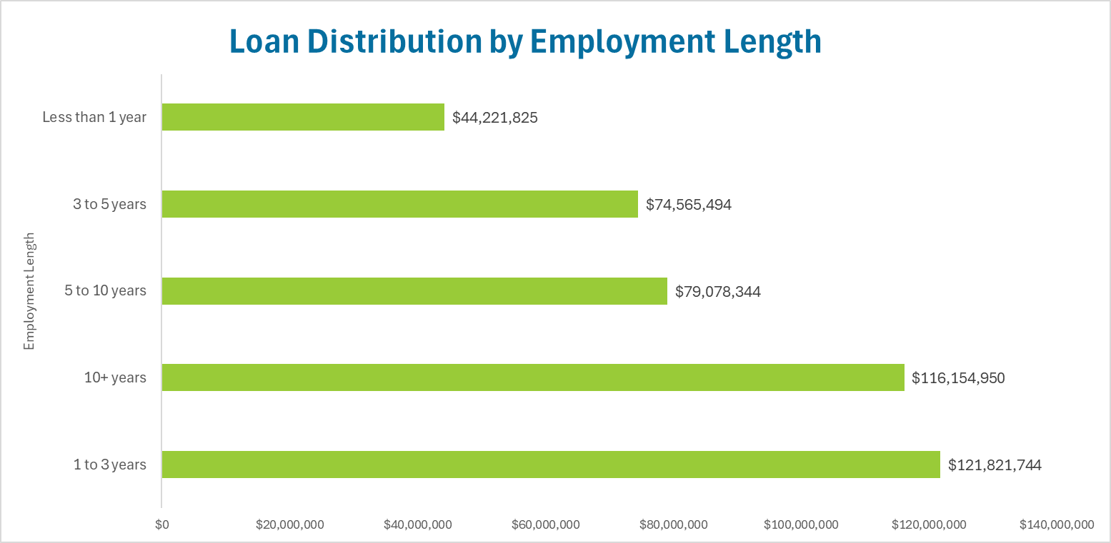

**Loan Amount Distribution**

* **Loan Distribution**:
  + Low (<$5,000), Medium ($5,001 - $15,000), High ($15,001 - $25,000), Very High (>$25,000).

**DTI and LTI Brackets**

* **DTI Brackets**
* 0% - 10%, 10% - 20%, 20% - 30%, 30% and above
* **LTI Brackets**
* 0.8% - 20%, 20% - 40%, 40% - 60%, 60% - 83

**4. Visualizations**

* **Default Loans Analysis**:
  + Compared characteristics of defaulted loans and non-defaulted loans using side-by-side visualizations.
* **Income Bracket vs. Loan Status**:
  + Created column charts comparing loan statuses and default rates across income brackets.
* **Interest Rate Analysis**:
  + Bar charts visualizing the relationship between interest rate and LTI, DTI, and default rate.

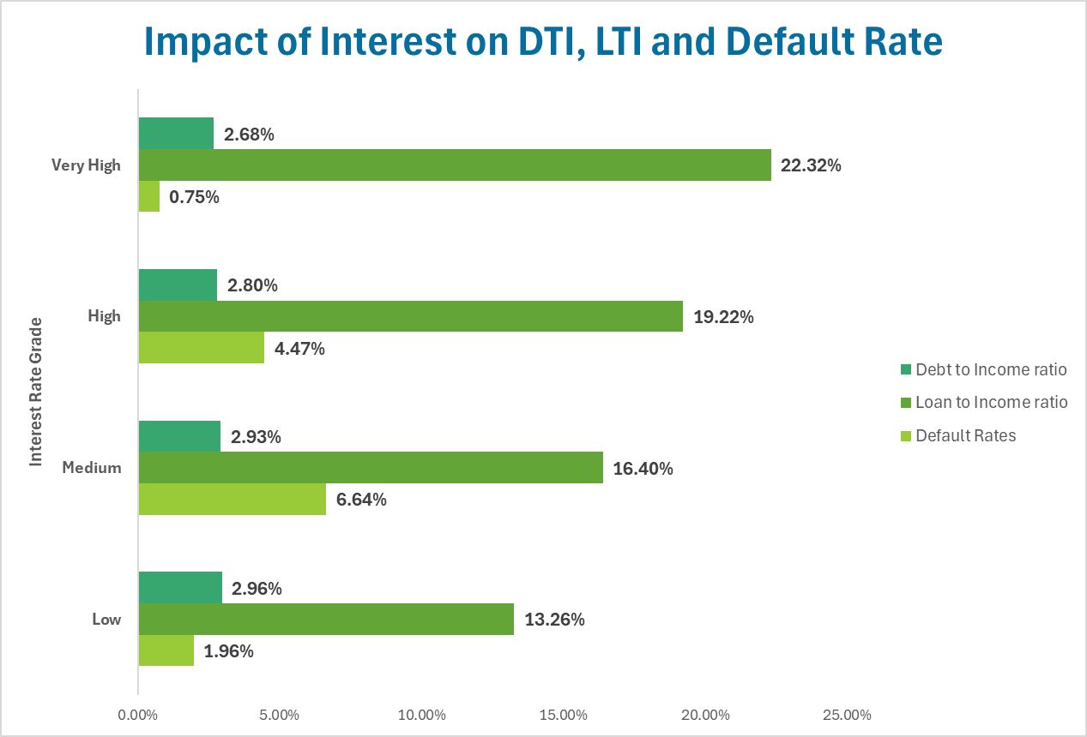

* **Employment Length vs. Default Rate**:
  + Column charts showing the relationship between employment length and default rate.

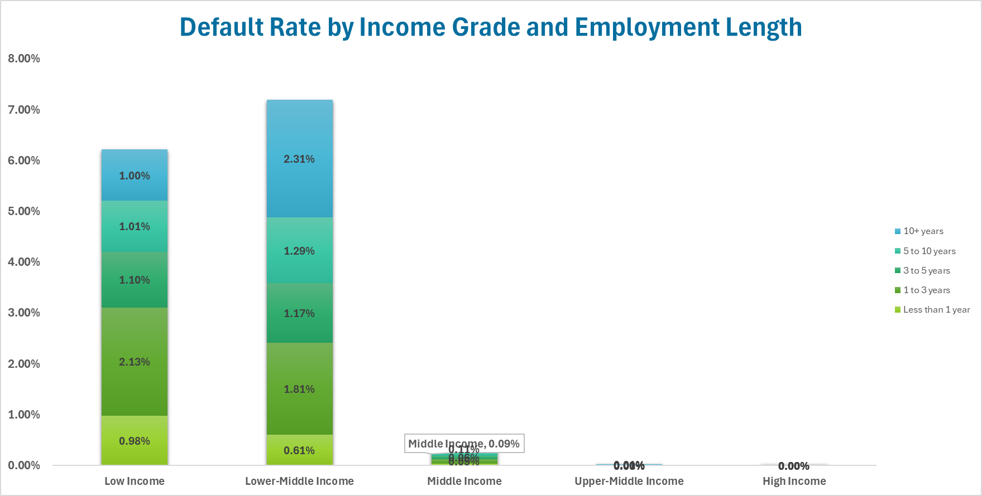

* **Loan Distribution by Purpose**:
  + Funnel Chart visualization of loan distribution by purpose.

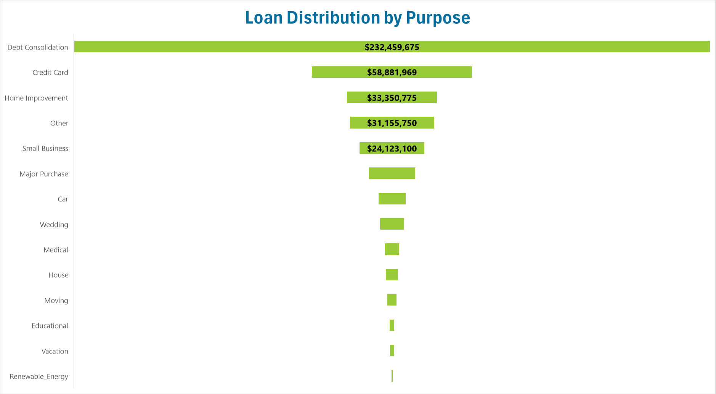

* **Approval Rate Analysis**:
  + Approval rates visualized by state using a pivot table.

**5. Dashboard Creation**

* **Map Visualization**:
  + Created a map of average approval rates across U.S. states.

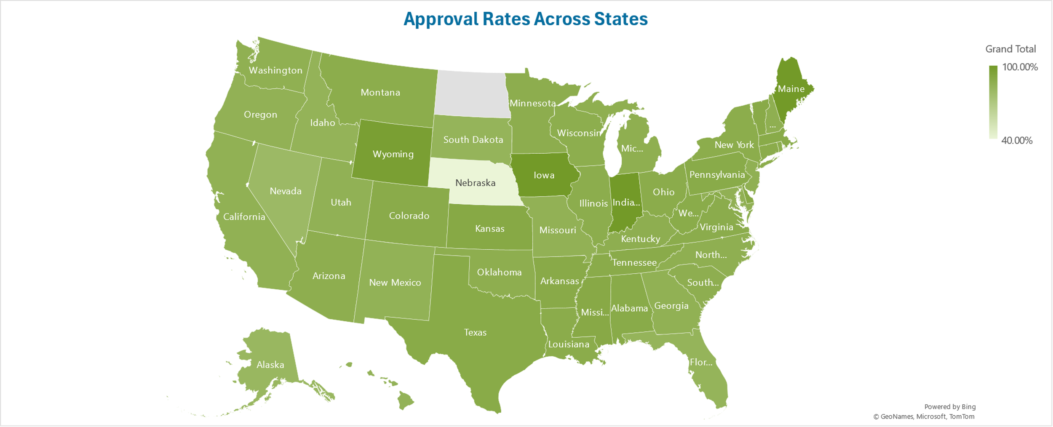

* **KPI Tracking**:
  + Key performance indicators (KPIs): total loans, total loan amount, total annual income, average DTI, and average LTI.

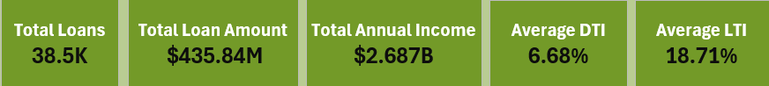

* **Pie Chart**:
  + 2D pie chart showing approved vs. default loans.

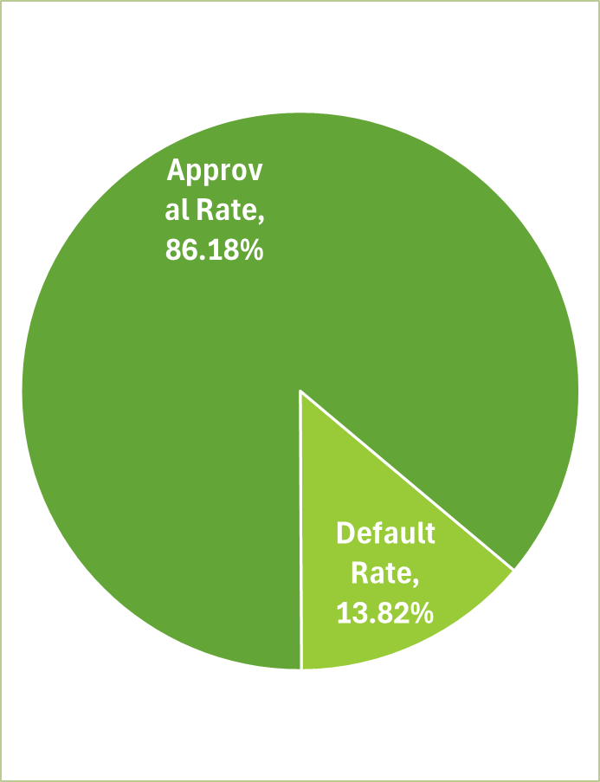

* **Final Dashboard**:
  + Combined all visualizations into 3 comprehensive dashboards to help TDI track loan performance and optimize strategies.

